Palestinian Central Bureau of Statistics (PCBS) and the Ministry of Telecom and Information Technology issue a joint press release on the eve of the World Telecommunication and Information Society Day 17/05/2021.

World Telecommunication and Information Society Day (WTISD) has been annually celebrated on May 17th since 1969 to mark the founding of ITU and the signing of the first International Telegraph Convention in 1865.

The COVID-19 Pandemic highlighted the crucial role of technology necessary to ensure the continued functioning of societies in different fields. The year 2021 holds the theme of “Accelerating Digital Transformation in Challenging Times” as the theme for WTISD, calling on all countries to take advantage of information and communication technology to develop digital policy strategies to respond effectively to challenging times.

More than 1000 establishments mainly work in the ICT sector.

Data of the Population, Housing and Establishments Census, 2017 indicated that the number of establishments working in the ICT sector accounted for 1,008 establishments out of the total economic operating establishments of (158,573), where this sector employed 9,200 persons in 2017.

The COVID-19 Pandemic cast its shadow on the information and communication sector and decreased the average sales/production of more than half during the closure period compared to the normal situation.

The COVID-19 Business Pulse Survey results in Palestine during the period (5/3/2020–31/5/2020) indicated that 90% of information and communication sector establishments reported that the sales/production size has decreased during the three months of the lockdown by 54% when compared with the normal situation. The results also indicated that 69% of the operating establishments in the information and communication sector (92% in the West Bank and 36% in the Gaza Strip) were closed for many days due to the restriction measures taken by the government during the mentioned period.

The use of Digital Solutions has been a lifeline for establishments during the Pandemic.
The COVID-19 Business Pulse Survey results in Palestine during the period (5/3/2020 – 31/5/2020) indicated that 13% of the establishments started using or have increased the use of the internet online social media networks, specialized apps, or digital platforms in response to the COVID-19 outbreak. In comparison, the primary use of such digital solutions was for marketing with 69%, 53% for business administration, and 40% for service delivery.

During three months (88 days), starting from March 5th until May 31st, 2020, establishments reported that the percentage of employees who were working remotely from home was 6% of the total number of employees; mainly in the telecommunication sector (18% of the total number of employees) and construction sector (8% of the total number of employees). The main results also showed that the highest percentage of employees working remotely from home was among large establishments with a rate of (12%).

Around 84% of households with children in the age of (4-18) years, their children participated in online educational activities.
The results of the Impact of COVID-19 Pandemic (Coronavirus) on the Socio-economic Conditions of Palestinian Households Survey during the period (23/8/2020–31/12/2020) indicated that 84% of households that have children in the age of (4-18) years in Palestine, their children participated in educational activities (online education) during that period; (81% in the West Bank and 87% in the Gaza Strip).

While 46% of households whose children did not participate in online education activities indicated that the lack of a computer (laptop, desktop, or tablet) at home or even its insufficient availability prevented their children from participating in online educational activities during the mentioned period (43% in the West Bank and 52% in the Gaza Strip).
In addition, 50% of the households whose children did not participate in online education activities indicated that the lack of internet access at home or its insufficient availability prevented their children from participating in online educational activities during the mentioned period (44% in the West Bank and 60% in the Gaza Strip).

More than 4.3 Million cellular mobile subscriptions
Data from the Ministry of Telecom and Information Technology indicated that there had been an expansion in the fixed network infrastructure, accompanied by increased use by households and institutions of this network and related services, especially the internet service. The number of landlines reached 466,283 telephone lines (Home, Commercial, Governmental) in Palestine at the end of 2020 compared with 360,402 lines at the end of 2010, with an increase of 29%.

Total Number of Cellular Mobile Lines in Palestine 2010-2020 (Thousands)
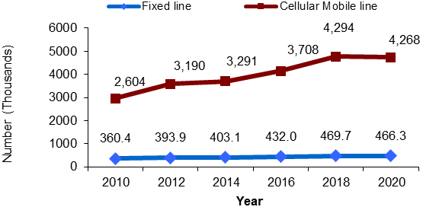

Meanwhile, there was an increase in the mobile cellular subscriptions by the end of 2020, reaching 4.3 million subscribers in Palestine compared to 2.6 million at the end of 2010, with 64%. In return, this is reflected in the mobile penetration rate per 100 persons that reached 83 mobiles at the end of 2020 compared to 64 mobiles at the end of 2010.

An increase of more than 200% in the number of ADSL subscribers
The total number of ADSL subscribers in Palestine increased to about 373 thousand subscribers by the end of 2020 compared with 119 thousand subscribers by the end of 2010, with an increase of 213%. The average internet speed was 13.5 Mbps at the end of 2020 compared with 0.5 Mbps at the end of 2010.

Total Number of ADSL Subscribers in Palestine, 2010-2020 (Thousands)

97% of Palestinian households have at least one cellular mobile line, with wide use of Smartphones
The data of the Household Survey on Information and Communications Technology, 2019 showed that 97% of the households in Palestine have at least one or more cellular mobile lines (97% in both the West Bank and the Gaza Strip). The results also showed that the percentage of households with one Smartphone or more was 86% in Palestine (91% in the West Bank and 78% in the Gaza Strip).

Also, the survey results showed that the percentage of individuals (18 years and above) who own a cellular mobile is 73% in Palestine (83% in the West Bank and 57% in the Gaza Strip).

Percentage of individuals (18 years and above) who own a cellular mobile by sex, 2019

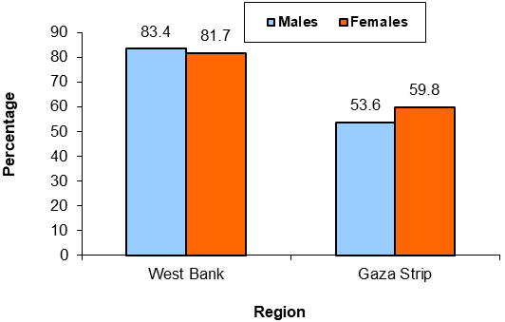

About one-third of households own a computer
The Household Survey results on Information and Communications Technology, 2019 showed that 33% of the households own a computer (desktop, laptop, or tablet) in Palestine (36% in the West Bank and 29% in the Gaza Strip). At the same time, the percentage of individuals (18 years and above) who used the computer from any location was 22% in Palestine (21% in the West Bank and 23% in the Gaza Strip).

The results also showed that the percentage of the households with children (10-17 years old) who are currently enrolled in education and have a computer (desktop, laptop, or tablet) is 44% in Palestine (50% in the West Bank and 36% in the Gaza Strip), while the percentage of households with individuals (18-24 years old) who are currently enrolled in education and have a computer (desktop, laptop or tablet) is 60% in Palestine (63% in the West Bank and 55% in the Gaza Strip).

About 80% of Palestinian households have access to the internet in their homes.
The Household Survey results on Information and Communications Technology, 2019 showed that 80% of the households in Palestine have internet access in 2019 (84% in the West Bank and 73% in the Gaza Strip). Moreover, the percentage of individuals (18 years and above) who used the internet from anywhere reached 72% in Palestine (76% in the West Bank and 67% in the Gaza Strip).

Moreover, the results showed that the percentage of the households with children (10-17 years old) who are currently enrolled in education and have internet access at home is 86% in Palestine (91% in the West Bank and 78% in the Gaza Strip). In contrast, the percentage of households with individuals (18-24 years old) who are currently enrolled in education and have internet service at home is 93% in Palestine (96% in the West Bank and 89% in the Gaza Strip).

Data excluded those parts of Jerusalem that were annexed by the Israeli occupation in 1967.

