Palestinian Central Bureau of Statistics (PCBS) and the Ministry of Communications and Information Technology issue a joint press release on the eve of the International Day for Society of Information 17/05/2017.

The world celebrates the world information society day this year under the title "Big Data for Big Impact," focusing on the power of Big Data and its impact on achieving the Sustainable Development Goals (SDGs) through exploring how to turn imperfect, complex, often unstructured data into actionable information in a development context. The technological developments have facilitated the emergence of Big Data, developing standards related to Big Data and identifying sources and uses of Big Data.

Number of Internet subscriptions ADSL is more than 320 thousand lines
The number of fix telephone lines in Palestine reached 432 thousands in 2016 while the number of mobile phone subscribers reached 3.6million; percentage of geographical coverage by mobile phone network is about 98%. The number of ADSL subscribers reached more than 320 thousands in 2016.

About a half of Palestinian households have a Smartphone
Currently, the estimated percentage of individuals who own a Smartphone is about a quarter of the total individuals who own a mobile phone, while the percentage of households in Palestine with a Smartphone is 52.1% in 2015, with 60.7% in the West Bank and 35.7% in Gaza Strip, with an increase of 2.0% compared with the year 2014.

Social Media Networks
The percentage of Internet users had increased for both sexes to 57.4% in 2015 based on the International Telecommunication Union estimates, with an increase of 6% compared with the year 2014, the number of users of social media reached 1,250,000 by two hours use per day.

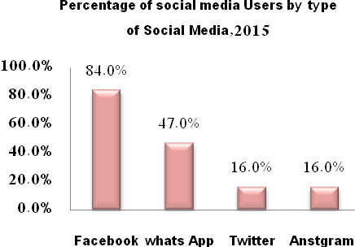

Informatics Threats

3.8% of Households in which a member uses the Internet was exposed to at least one Informatics threat on Internet sites in 2016, by 2.9% in the West Bank and 5.4% in Gaza Strip.
Percentage of Internet Users in Households who were Exposed to Informatics Threats on the Internet by Region, 2016

Gaza Strip | West Bank | Palestine | Informatics Threats
3.6 | 1.7 | 2.4 | Entry of Viruses through the Internet
0.4 | 0.5 | 0.5 | Damage of Information
2.1 | 1.0 | 1.4 | Publish of Pornographic Content
1.9 | 0.8 | 1.2 | Theft of Personal Data
0.1 | 0.0* | 0.0* | Theft of Credit Card Numbers
0.0* | 0.0* | 0.0* | Others

• Value Less than 0.05

The Economics of Informatics and Communications sector
The data indicated that establishments that work in information technology and communications sector had accounted for 0.5% of the total economic establishments in 2015, with 1.6% of the total employees, and the production of this sector accounted for 7.3% of the total production of the economic sectors. The information technology and communications sector added value exceeded half of billion dollars, by 4.1% of GDP (Gross Domestic Product) in various economic sectors for the year 2015.

