Palestinian Central Bureau of Statistics (PCBS) & Ministry of Health (MOH)

Preliminary Results of Palestinian Health Accounts in Palestine* for 2015

The Palestinian Central Bureau of Statistics (PCBS), in partnership with the Ministry of Health, presents the annual Palestinian Health Accounts report for 2015**.

The preliminary results showed an increase in the total current expenditure on health to attain USD 1,321.3 millions in 2015 compared to USD 1,234.2 in 2014.

The percentage of total health expenditure to Gross Domestic Product (GDP) at current prices for Palestine increased from 10.7% in 2015 to 9.8% in 2014.

Total health expenditure per capita was USD 282.2 in 2015 compared to USD 271.2 in 2014.

Health Expenditure by Source of Funding

The contribution of the Government schemes and compulsory contributory health care financing schemes to financing health expenditure was 33% in 2015; while the contribution of central government as financing agent was 41.1% in 2015 compared to 42.6% in 2014.

The highest contribution of to the financing of health expenditure was 45.5% in 2015 through Household out-of-pocket payment (scheme), while it was 43.1% in 2014.

In 2015, the source for health expenditure was 29.7% from government domestic revenue transfers, 52.5% as other domestic revenues n.e.c., and 4.4% as Direct foreign transfers.

Percentage of current expenditure on health in Palestine* distributed by financing agents for 2015
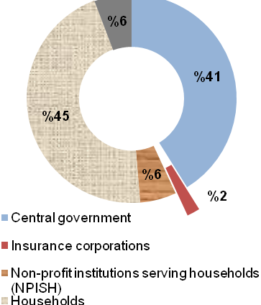

2Health Expenditure by Function of Health care

The primary results showed that the percentage of total current expenditure on health distributed by function of care for the curative care services was the highest contribution and it totalled 73.5% in 2015 while 72% in 2014.

The contribution of medical goods provided to outpatients was 18% in 2015 comparing to 18.5% in 2014.

Health Expenditure by Health care Provider

The contribution of hospitals to total expenditure on health was 41.6% in 2015. The general hospitals recorded the highest contribution with 73.8%, while 24.5% of specialised hospitals.

Providers of primary health care (ambulatory health care) recorded 20.4% during 2015 compared to 20.8% during 2014. In 2015, total health expenditure through retailers and other providers of medical goods was USD 237.4 million, which means 18% from the total health expenditure.

*The data excludes that part of Jerusalem which was annexed forcefully by Israel following its occupation of the West Bank in 1967.
** Depending on the adopted System of Health Accounts (SHA 2011), there is a difference in pubished data in this report and data that have been published previously. In Addition to that, Health expenditure excludes gross capital formation.

