Palestinian Central Bureau of Statistics (PCBS)

Levels of Living in Palestine, 2017

The Average Monthly of Per Capita Expenditure was around 170 JDs.

The monthly average of per capita expenditure in Palestine was 169.5 JDs (220.1 JDs in the West Bank, and 91.2 JDs in Gaza Strip).

Around 31% of Total Expenditure was for Food

Percentage of per capita expenditure on food groups to the total per capita expenditure was 30.5% (29.1% in the West Bank, and 35.7% in Gaza Strip), followed by the percentage of per capita expenditure on transport and communications by 18.5%, and 8.7% on housing, and the lowest percentage of expenditure was on recreation group by 1.5%, and second lowest percentage was on personal care group by 2.1% in Palestine.

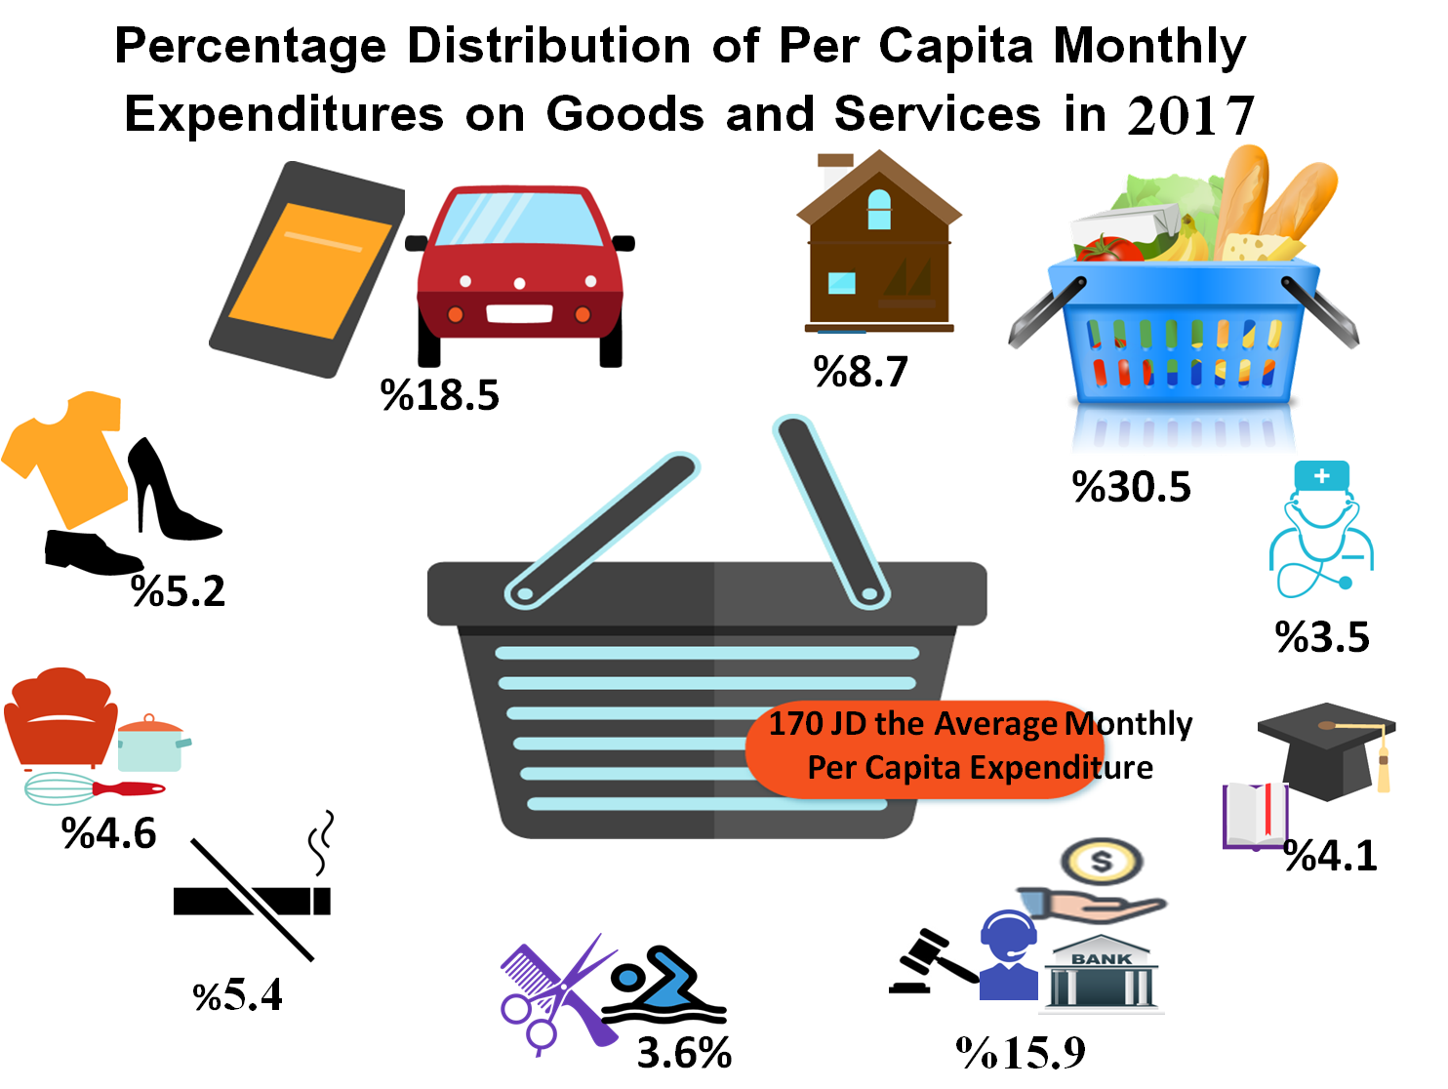

Between 2011 and 2017: An Increase in Per Capita Expenditure in the West Bank against a decrease in Gaza Strip

It is noticed that there was an increase in the monthly average of per capita expenditure in 2017 compared to 2011 in the West Bank; in 2017 the per capita expenditure was 220 JDs in the West Bank, while it was 188 JDs in 2011, with an increase of 17.0%. While in Gaza Strip the average monthly of per capita expenditure decreased in 2017 compared to 2011 by around 17%, as the per capita expenditure was 91 JDs in 2017, while it was 110 JDs in 2011.

The same trend of change remained even at real prices (without inflation effect). As the per capita expenditure increased in the West Bank by the real prices but with less percentage than it was in the nominal prices. The same as for Gaza Strip but in different direction, as the per capita expenditure decreased in the real prices but with more percentage than it was in the nominal prices. That means there was an improvement in the level of living in the West Bank, but in the other side there was a deterioration in levels of living in Gaza Strip.

A Change in Patterns of Expenditure was in 2017
A Decrease in the Share of Expenditure of Food, Clothes, Household Appliances and Personal Care
The data revealed that there was a change in expenditure patterns of Palestinian individual\household between 2011 and 2017. The share of food decreased in 2017, as it was 35.9% in 2011 and it became 30.5% in 2017. The share of clothes and footwear also decreased, as it was 6.6% in 2011 and became 5.2% in 2017. The share of household appliances which includes (furniture and utensils and household operation groups) also decreased in 2017, as it was 5.8% and became 4.6%. And the share of personal care decreased from 2.8% in 2011 to 2.1% in 2017.

An Increase in the Expenditure of Transport & Communications, Cash Transfers, Education and Smoking
The data revealed that the share of transport and Communications group increased, as it was 14.7% in 2011 and reached 18.5% in 2017. Another increase was in cash transfers, which increased from 3.5% in 2011 to 7.6% in 2017. The share of education also increased, as it was 3.0% in 2011 and it increased to 4.1% in 2017. The smoking (tobacco) share also increased, as it was 4.6% in 2011 and it reached 5.4% in 2017.

The Change in Expenditure Patterns is moving in the same Direction in the West Bank and in Gaza Strip except for Three Groups
The change in expenditure patterns (either increasing or decreasing) in Palestine was the same for the West Bank and Gaza Strip in all groups except for the following three groups: Housing, Medical Care, Non consumption Expenditure.
The first group was housing, its share of expenditure decreased in the West Bank from 8.7% to 8.4%, while it increased in Gaza Strip from 8.9% to 9.8%, and remained the same on national level of 8.7% in 2017. The second was the medical group, where its share decreased in the West Bank from 3.8% to 3.4%, while in Gaza Strip there was an increase from 3.3% to 4.0%, and on the national level the share of medical care decreased from 3.7% in 2011 to 3.5% in 2017. The third group was the non consumption expenditure group, which includes: gifts, loans interests, social insurance; the share of this group increased in the West Bank, but decreased in Gaza Strip, and it increased on the national level from 5.2% in 2011 to 6.2% in 2017.
Percentages of Per Capita Expenditure on Selected Groups, 2011, 2017
The Average Monthly Expenditure of Household was around 935 JDs
According to the results of the Palestinian expenditure and consumption survey 2017, the average monthly expenditure of household on various goods and services amounted to 934.9 JDs (for household size of 5.5 of individuals), and it was 1143.6 JDs in the West Bank (for household size of 5.2 individuals) compared to 556.0 JDs in Gaza Strip (for household size of 6.1 individuals).
A change in household size was shown through the survey data. The average of household size decreased in Palestine in 2017, as it was 6.0 individuals in 2011 and it became 5.5 individuals in 2017. This decrease was also shown in the West Bank and Gaza Strip.
In the West Bank, the household size was 5.6 individuals in 2011 and it became 5.2 individuals in 2017.
And in Gaza Strip, the household size decreased from 6.6 individuals in 2011 to 6.1 individuals in 2017.

Around 29% of the Palestinians were Poor in 2017

29.2% of the Palestinians were below the poverty line in 2017; that means their household consumption was below the poverty line. The poverty line for household of 5 members (2 adults and 3 children) was 2470 NIS, and 16.8% of the Palestinians suffered deep poverty in 2017, and the deep poverty line was 1974 NIS. | 

More than Half the Population were Poor in Gaza Strip in 2017
The percentage of poverty was 13.9% in the West Bank, while it reached more than half of population in Gaza Strip as it was 53.0%, which means four times higher than poverty percentage in the West Bank. As for the deep poverty line, 5.8% of individuals were below the deep poverty line in the West Bank and 33.8% of individuals in Gaza Strip, so the deep poverty percentage in Gaza Strip was six times higher than the West Bank.

An Increase in Poverty Percentages in 2017
The data showed an increase in poverty percentages in 2017 compared to 2011. The poverty percentages were 25.8% in 2011 while it increased by 13.2% in 2017 to reach 29.2% of individuals were below poverty line. Deep poverty percentages also increased in 2017, as it was 12.9% in 2011 and it increased to 16.8% in 2017 with an increase by 30.2%.

This increase in poverty percentages was mainly because of the sharp increase in poverty in Gaza Strip. It is worth mentioning that the situation of level of living in Gaza Strip became worse than it was in 2011. Poverty among individuals in Gaza Strip was 38.8% in 2011 while it jumped to 53.0% in 2017 with 37% increase. In West Bank, the situation was different, as the poverty percentages decreased from 17.8% in 2011 to 13.9% in 2017 with about 22.0% decrease.

Poverty Percentages among Individuals according to Monthly Consumption Patterns (2009-2011, 2017)

Deep poverty percentages also increased significantly in Gaza Strip, as the deep poverty percentage was 21.1% in 2011 and became 33.8% in 2017 with an increase by around 60%. In West Bank, there was a decrease in deep means poverty percentages, as it was 7.8% in 2011 and became 5.8% in 2017 with a decrease by 25.6%.
The significant increase in poverty indicators in Gaza Strip was the cause of the increase in poverty indicators on the national level.

