Palestinian Central Bureau of Statistics (PCBS)

Decrease in the number of building licenses in Palestine* in the first quarter of 2021 compared with previous quarter, due to the decrease in the number of new building licenses

A total of 2,245 building licenses were issued in the first quarter of 2021, of which 1,285 are new buildings.

The total number of building licenses issued in the first quarter of 2021 decreased by 18% compared with the fourth quarter of 2020 and increased by 2% compared with the first quarter of 2020, where the number of new building licenses decreased by 29% compared with the fourth quarter of 2020 and decreased by 17% compared with the first quarter of 2020.

The area of licensed buildings (residential and non-residential) totaled 961 thousand m², of which new buildings made up 693 thousand m² and existing buildings comprised 268 thousand m².

The total number of licensed dwellings was 4,287 with a total area of 698 thousand m², of which 2,937 were new dwellings with a total area of 485 thousand m² and 1,350 were existing dwellings with a total area of 213 thousand m².

The number of new dwellings in the first quarter of 2021 decreased by 32% compared with the fourth quarter of 2020 and decreased by 15% compared with the first quarter of 2020.

Number of Building Licenses Issued in Palestine* during the period, First Quarter 2020 - First Quarter 2021

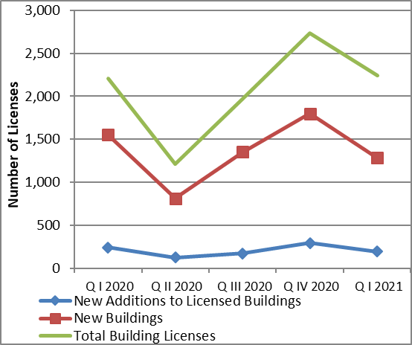

*Data excluded those parts of Jerusalem which were annexed by Israeli occupation in 1967.

