Palestinian Central Bureau of Statistics (PCBS)

Press Release on the Results of the Labour Force Survey,2018

A slight decrease in unemployment rate in the West Bank and a sharp increase in Gaza Strip

The unemployment rate between the West Bank and Gaza Strip still high in 2018; 52% in Gaza Strip compared with 44% in 2017, while in the West Bank it was 18% and 19%, respectively. 25% for males and 51% for females in 2018.

Unemployment Rate in Palestine by Region, 2015-2018
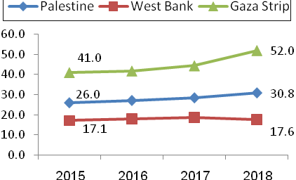

A large gap in the labour force participation rate between males and females

7 out of 10 of males are participated in the labor force, compared with 2 out of 10 of females.

There a significant increased in the participation rate of females between the Gaza Strip and the West Bank, where the percentages were 26% in Gaza Strip and 18% in the West Bank.

The number of the employment in the local market increased between 2017 and 2018

The number of the employment in the local market increased from 823 thousand in 2017 to 827 thousand in 2018, which it increased in the West Bank by 5%, while in Gaza Strip decreased by 9% for the same period.

The services sector and other branches was the biggest employer in the local market, where the percentage of employment was more than one third of employed in the West Bank compared with more than half in Gaza Strip.
The average weekly hours worked by wage employees in the West Bank was 43.8 hour compared with 37.3 hour in Gaza Strip. And the average number of days worked per month was 22.8 day in West Bank and 22.6 day in Gaza Strip.

The number of employed in Israel and Israeli settlements was increased by 5 thousand between 2017 and 2018

The number of employed in Israel and Israeli settlements was about 127 thousand in 2018, and the largest share of those 59% had a permit, and 30% worked without any permit, while who had an Israeli identity card or foreign passport about 11%.

The number of employees in Israeli settlements was 22 thousand in 2018 compared with 21 thousand in 2017.

The construction sector recorded the highest employment rate in Israel and Israeli settlements, which was 64% of the total Palestinian employment in the Israel and Israeli settlements.

The average daily wage for the wage employees in Israel and Israeli settlements increased between 2017 and 2018 by 16 NIS, to reached 243 NIS.

7 out of 10 of employed individuals are wage employees

%70 of employed individuals are wage employees, 26% are self- employed and employers, while 4% are unpaid family members.

Half of the wage employees in the private sector hired without any contract

%50 of wage employees in the private sector hired without any contract, and 25% of wage employees contribute to a pension fund. In contrast, less than half of wage employees women (43%) have paid maternity leave.

30% of wage employees in the private sector received less than the minimum wage (1,450 NIS) in Palestine

There had a significant decreased in the wage employees in the private sector received less than the minimum wage in the West Bank from 18% to 12% between 2017 and 2018, and the percentage in Gaza Strip decreased from 81% to 72% during the same period.

Despite the low rate in the West Bank and Gaza Strip, the gap in the monthly wage rate remains high; 671 NIS in Gaza Strip compared with 1,076 NIS in the West Bank.

High percentage of child labor in the West Bank than in Gaza Strip
4% of children aged (10-17 years) were employed; 5% in the West Bank and 2% in Gaza Strip.

