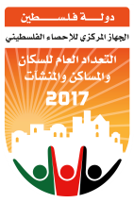 | State of Palestine  Palestinian Central Bureau of Statistics | 

Palestinian Central Bureau of Statistics (PCBS)

International Youth Day,12/08/2017

On the eve of International Youth Day and under the theme “Youth, Peace and Security”, the Palestinian Central Bureau of Statistics (PCBS) issues a press release reviewing the situation of young people in the Palestinian society.

On December 9th, the UN Security Council unanimously adopted Resolution number 2250 on "Youth, Peace and Security", which is the first of its kind, aiming to enhance the participation of youth in these areas. The Council urged Member States to consider ways to increase the overall representation of the youth in decision-making process at all levels to contribute in preventing and resolving conflicts.

3 out of 10 individuals in the Palestinian society are young
The percentage of youth in the age group of (15-29) in Palestine comprises 30% of the total population, distributed by 36% in the age group of (15-19) years and 64% in the age group of (20-29) years old. Where the sex ratio among the youth is 104 males per 100 females, noting that the population estimates in Palestine in mid-2017 indicate that the total population approximately reached 4.95 million.

Population Pyramid in Palestine, Mid-2017
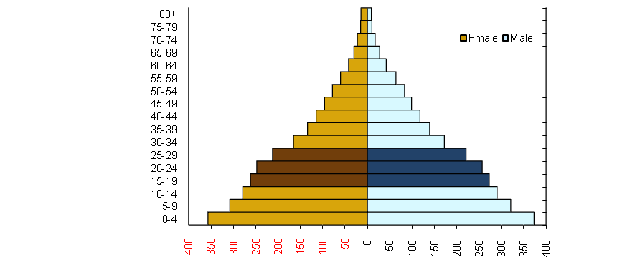

7 out of 10 households in Palestine have at least one young person
The 2015 Palestinian youth survey showed that the percentage of households headed by a young person aged (15-29) reached 14% (13% in the West Bank and 17% in Gaza Strip). The data also showed that 72% of households have at least one young person (71% in the West Bank and 74% in Gaza Strip).

High unemployment among the youth
The unemployment rate among young people aged (15-29) reached 40% among the youth involved in the labor force. In which the highest rate of unemployment among individuals within the age group of (20-24) reached 44% compared to 36% among individuals within the age group of (25-29).

Unemployment amongst young graduates exceeded 50%
The unemployment rate among young graduates reached 53% during the first quarter of 2017 (36% for males and 69% for females). The graduates of natural sciences specialization scored the highest unemployment rate reaching 70% (48% for males and 78% for females). Unemployment rate among Health specialization scored the lowest reaching 32% (19% for males and 49% for females).

16% of the youth completed the transition from education to labor market, 2015
The results of the survey showed that a minority of young people 16%completed the transition to reach a satisfactory working status in 2015 compared to 15% in 2013 (28% for males and 4% for females in 2015). While the participation rate of the youth transitioning between the years 2013 and 2015 increased from 39% in 2013 to 42% in 2015 (25% for males, 59% for females).
27% of the youth work in the sectors of trade, restaurants and hospitality
The percentage of the youth working in the services sector reached 24% in the first quarter of 2017 (17% for males and 76% for females) compared with 27% working in trade, restaurants and hospitality sector (30% for males and 7% for females), while 18% work at the construction sector (21% for males and 1% of females), and 17% of the youth work in the industrial sector ( 18% for males and 8% for females) , while the ratio of workers in the agriculture sector reached 8% (8% for males and 7% for females).

More than half of the youth population aged (15-29) years in Gaza Strip reported interest in participating in an election event
40% of the youth aged(15-29) years reported interest in participating in an elections event (29% in the West Bank compared to 57% in Gaza Strip). While 29% reported they would probably participate, 13% said they would not probably participate and 18% said they definitely would not participate (16% in the West Bank and 21% in Gaza Strip) according to the Palestinian Youth Survey 2015.

8 out of 10 people believe that ending the occupation and building the state is the first priority in the Palestinian society
In regard to priority issues of the Palestinian youth, the youth survey indicated that 79% of young people aged (15-29) believe that ending the occupation and building the state is the main issue of priority for the Palestinian society. In the second place came the issue of raising the standard of living with a rate of 7%. The consensus is noticeable on those priorities among the youth (males and females) in the West Bank and Gaza Strip.
38% of the youth (15-29) years are enrolled in education
Statistics for 2016 showed that 38% of young people (15-29) years are enrolled in education; among of which 82% of young people aged(15-17) years, 45% of the age group (18-22) years and 8% of the age group (23 -29) years. Statistics indicated that the total dropout rates (those who left school before completing their education) among the youth (15-29) years in Palestine were 34% (42% for males and 27% for females). The secondary school dropout rate in the 2014-2015 scholastic year among youth (15-29) years in Palestine was 2.0% (2.1% for males and 1.8% for females

4 out of 100 youth have difficulty/disability
The Data of the Palestinian Youth Survey 2015, showed that the percentage of youth (15-29) years who face difficulty/disability was 3.6% (3.7% in the West Bank and 3.6% in Gaza Strip). The percentage of males with difficulty/disability was 4.9% compared to 2.3% of females.

Percentage of the Youth aged (15-29) years by Difficulty/Disability, Sex and Region, 2015

Sex | Palestine | West Bank | Gaza Strip
Both sexes | 3.6 | 3.7 | 3.6
Males | 4.9 | 4.6 | 5.3
Females | 2.3 | 2.7 | 1.5

2 out of 10 youth smoke
The data of the Palestinian Youth Survey 2015 showed that 24% of the youth smoked (30% in the West Bank versus 14% in Gaza Strip). Gender variances were high with 41% of males smoking compared to 5% of females.

Percentage of the Youth aged (15-29) years Smokers by Sex and Region, 2015

Sex | Palestine | West Bank | Gaza Strip
Both sexes | 23.5 | 29.5 | 14.0
Males | 40.9 | 49.5 | 26.6
Females | 5.4 | 8.1 | 1.0

20% of the youth in Palestine participated in volunteer work
The data of the Palestinian Youth Survey 2015 showed that the youth aged (15-29) years who participated in volunteer work in the year 2014 reached 20%. 11% of those participated in non-financial charity activities (helping the poor or hardship cases), while 7% contributed to community development activities, 5% to educational activities, 6% to fundraising and 1% in other volunteer work.

Percentage of the Youth aged (15-29) years by Participating in Volunteer Activities during the year prior to the survey, Sex and Region, 2015

Sex | Palestine | West Bank | Gaza Strip
Both sexes | 19.6 | 18.1 | 21.8
Males | 26.0 | 23.5 | 30.0
Females | 12.8 | 12.5 | 13.3

7 out of 10 youth in Palestine use computers
The data of the Palestinian Youth Survey 2015 also showed that the percentage of the youth aged (15-29) years who use a computer reached 70% (75% in the West Bank compared to 62% in Gaza Strip). Of those 74% were males compared to 66% females.

More than one third of the young people in Gaza Strip desire to immigrate abroad
The results of the Palestinian Youth Survey, 2015 showed that about 24% of the young people in Palestine in the age group of (15-29) have a desire to immigrate abroad and it seems that the prevailing situation in Gaza Strip is not changing this trend. The percentage of the youth wishing to immigrate in Gaza Strip reached 37% compared to 15% in the West Bank. It is also notable that young males are more likely to think about immigration than young females, with 29% for males and 18% for females.

