Palestinian Central Bureau of Statistics (PCBS)

Press Release on the Results of the Labour Force Survey First Quarter
(January – March, 2021) Round

The Impact of the Coronavirus Pandemic on the Labour Market

The labour market is considered the most affected sector during the ongoing Coronavirus pandemic since the beginning of March 2020, as the Palestinian government has taken several measures in addition to an emergency plan to limit the outbreak of the pandemic. Thus, the data below reflects the most important indicators of the Palestinian labour market during the 4th quarter of 2020 as follows:.
The number of employed persons decreased by one thousand in the 1st quarter of 2021
The number of employed persons (excluded workers abroad) decreased from 995 thousand in the 4th quarter of 2020 to 994 thousand in the 1st quarter of 2021, by 1% compared to the 4th quarter of 2020. It decreased in the West Bank by 3.5% compared to the 4th quarter 2020, while it increased by 11.6% in Gaza Strip for the same period.

The largest decreased reported among wage employees, as this number decreased by 23 thousand employed persons, as for other employed persons, the number has increased between the 4th quarter 2021 and 1st quarter 2021 by 12 thousand for own account employed (employers and self employed), also it increased by 10 thousand for unpaid family workers.

Slight Increase in employed persons who were absent from their work due to the pandemic
The results showed that the number of employed persons who were absent from their jobs increased from 61 thousand in the 4th quarter 2020 to 62 thousand in 1st quarter 2021 with an increase by 1%. The reasons for this increase was due to Corona pandemic and return back gradually to closure especially in March 2021.

An increase in the number of employed persons in the local market between the 4th quarter 2020 and 1st quarter 2021
The number of employed persons in the local market increased from 853 thousand employed persons in the 4th quarter of 2020 to 856 thousand employed persons in the 1st quarter of 2021, this increase was 11.6% in Gaza Strip, while it decreased about 3.5% in the West Bank for the same period.

The results showed that most of the activities witnessed an increase in the number of employed persons during the 4th quarter of 2020 are those employed in other services, constructions, then manufacturing, agriculture and transportation, but trade commerce and hotels sector witnessed a decrease in the number of employed persons.

The average weekly working hours for wage employees in the West Bank was 42.4 hours per week compared to 35.9 hours in Gaza Strip. The average monthly working days was 22.5 working days in the West Bank compared to 21.9 working days in Gaza Strip.

A decrease in the number of employed persons in Israel and Israeli settlements by 4 thousands between the 4th 2020 and the 1st quarter of 2021
The number of employed persons in Israel and settlements decreased from about 142 thousand employed persons in the 4th quarter 2020 to 138 thousand employed persons in the 1st quarter of 2021; the highest decrease was in the number of workers in manufacturing by 3 thousands followed by commerce, restaurants and hotels and constructions by one thousand for each of them. While the number of employed persons in Israeli settlements increased from 20 thousand in the 4th quarter 2020 to 21 thousand in the 1st quarter 2021.
The average daily wage for the wage employees in Israel and Israeli settlements increased between the 4th quarter 2020 and the 1st quarter 2021 from 261 NIS to 264 NIS.

7 out of 10 employed persons are wage employees
72% of employed persons are wage employees, 24% of employed persons are self-employed and employers, and 4% are unpaid family members.

About half of the wage employees in the private sector were hired without any contract.
51% of wage employees in the private sector were hired without any contract, and 32% of wage employees receive a contribution to a pension fund/end of service compensation. Moreover, more than half of wage female employees (59%) have a paid maternity leave.

29% of wage employees in the private sector receive less than the minimum wage (1,450 NIS) in Palestine
The percentage of wage employees in the private sector who receive less than the minimum wage in the West Bank increased slightly between the 4th quarter 2020 and the 1st quarter 2021 from 6% to 7%, (The number increased from 17 thousand to 18 thousand), and also the percentage increased from 79% to about 81% in Gaza Strip (The number increased from 68 thousand to 85 thousand) during the same period.

The monthly minimum wage in Gaza Strip was (655 NIS) compared with (1,114 NIS) in the West Bank.

An increase in the labour force participation rate in Gaza Strip
The participation rate in the labour force increased from 41% in the 4th quarter 2020 to 43% in the 1st quarter 2021. Also, data indicated that this percentage increased in Gaza Strip from 32% to 39%, while it remains at the same level in the West Bank at 46% during the same period.
The male participation rate increased from 65% in the 4th quarter of 2021 to 69% in the 1st quarter 2021, while for females it remains at the same level 16% during the same period.
This explains why the unemployment rates increased this quarter, where was the number of the labour force participants increased about 78 thousand while the increase in the number of employed was about one thousand, so the increasing in the number of employed persons was less than the increasing in the number pf participants, so decreasing number of unemployed persons, which lead the increase in the number of unemployed, the unemployment rate in the 1st 2021 quarter was about 28%, while the total underutilisation of labour was about 36%, according to the revised International Labour Organization standards (ICLS-19th).

The number of unemployed persons reached 383 thousand in the 1st quarter of 2021; of which 228 thousand persons in Gaza Strip and 155 thousand persons in the West Bank. Hence, the disparity remains large in the unemployment rate between the West Bank and Gaza Strip, as this rate reached 48% in Gaza Strip compared to 17% in the West Bank. As for the sex level, the unemployment rate for males in Palestine reached 24% compared to 43% for females.

Within the same context, the total underutilisation reached 550 thousand persons, as this number includes 84 thousand discouraged job seekers and 30 thousand in time-related underemployment.

Unemployment Rate (ICLS 19th) by Region, Q1 2018 – Q1-2021

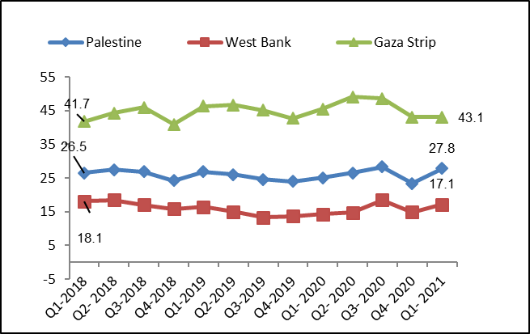

Includes: Public administration and defence; compulsory social security, Education, Human health activities, Social work activities without accommodation, Creative, arts and entertainment activities, Libraries, archives, museums and other cultural activities, Sports activities and amusement and recreation activities, Activities of membership organizations, Other personal service activities, Activities of households as employers of domestic personnel and Activities of extraterritorial organizations and bodies

