International Women’s Day 2012

About half of the Palestinian society are females
The estimated population at end of 2011 was 4.2 million in the Palestinian territory of whom 2.2 million are males and 2.0 million females. In addition, males comprise 50.8% of total population compared to 49.2% for females. In other words; for every 100 person, there are 49 females. Thus, the sex ratio was 103.2.

More than half of the females aged 15 years and above are married
Of every 10 females aged 15 years and above, there are 6 of them got married. Conversely, there are 3 women out of 10 are never being married, 6.1% are widowed, while 1.3% are divorced ,1.8% are engaged for the first time and not yet married and 0.2% are separated.

Decline in illiteracy percentages among women
Illiteracy percentages among females three and a half times higher than among males, the rate of illiteracy among males reaches 2.1% compared to 7.4% among females in 2011, while the literacy percentages among females was 15.3% in 2001. On the other hand the percentage of women with associated diploma and above was about 17% in 2001.

Literacy rate among men and women aged 15 years and above during 2001-2011
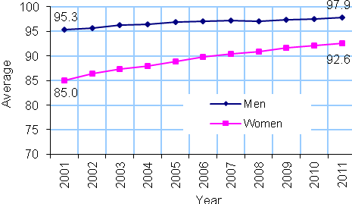

Issued on 8/3/2012

Limited participation of women in the labor force
Despite the rise in the participation rate of women in the labor force during the past ten years, still the rate is considered low; 16.6% out of females in the labor force in 2011 compared to 10.3% in 2001. Participation rate of men in the labor force is still four times higher than that of females.

On the other hand, there is a gap in the average of daily wages between men and women; i.e. the average of daily wages for women represents 84% out of the men's average of daily wage in 2011.

Participation of men and women 15 years and above in the labor force during
2001-2011
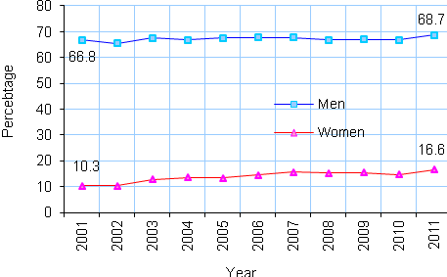

Higher unemployment percentage among women
Participation of women in the labor force is considered important for sustainable development. But the unemployment percentages is still increased between women. It was 28.4% in 2011 compared to 13.8% in 2001. It's worth to mention the unemployment percentages was the highest among women with 13 schooling years; 38.8% in 2011.

Unemployment rate among men and women 15 years and above 2000-2011.
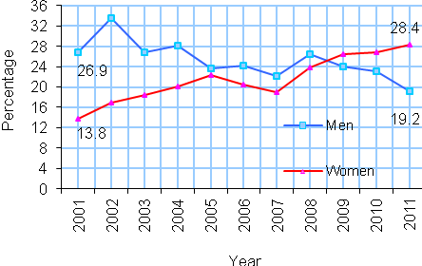

Higher poverty percentages among women-headed households
The proportion of deep poverty among households headed by women was about 15% in 2010; 20.6% in Gaza Strip compared to 12.5% in West Bank. On the other hand, the poor households in Gaza Strip is more impoverished than those in West Bank, since absolute poverty percentage was 3.2% and 2.2% respectively.

Percentage of deep poverty rate By sex of household, 2010

Gaza Strip | West Bank | Sex of household
23.2 | 8.6 | Males
20.6 | 12.5 | Females

Multiple sources of violence against women
37.0% of ever married women were exposed to one form of violence by their husbands in 2011. The highest percentage of violence that had been directed against wives by husbands was in Jericho & Al-Aghwar governorate in West Bank at 47.3% and the lowest percentage was in Ramallah & Al Bireh governorate at 14.2% while in Gaza Strip, this percentage reached its highest in Gaza governorate at 58.1% while the lowest percentage was in Rafah governorate at 23.1%.

On the other hand, 5% of women were subjected to psychological violence in streets by other individuals and 1.3% were subjected to sexual harassment while 0.6 % of women were subjected to physical violence in the same place, compared 4.0% of women were exposed to psychological violence by service providers and other individuals who were presented at such places of public services whether health , social, and cultural services.

Women suffer more chronic diseases than men
20.1% of women at age 18 and over suffer from at least one chronic disease, compared to 16.2% among men in the same age group, the prevalence in West Bank is higher than in Gaza Strip; 21.5% and 17.6% respectively. Obviously hypertension, diabetes and arthritis diseases are the most prevalent among women.

Women and men 18 years and over with certain chronic diseases, 2010
Sex |  | Disease
Males | Females | Disease
5.7 | 9.8 | Hypertension
5.3 | 6.6 | Diabetes
1.8 | 1.6 | Ulcer
2.7 | 2.4 | Cardiac
0.2 | 0.4 | Cancer
3.2 | 5.8 | Arthritis

Palestinian women in public life
13.2% of the members of the Legislative Council in 2010 were women. And the percentage of women in the Legislative Council in Gaza Strip is more than in West Bank; 14.9% and 12.1% respectively. 11.3% of judges are women, and the percentage of female judges in both West Bank and Gaza Strip; reached almost 12% in West Bank and about 10% in Gaza Strip. Only 10% of editors of daily papers in the Palestinian territory are women.

For more details, please contact:
Palestinian Central Bureau of Statistics
Ramallah-Palestine
Phone: ++ (970/972) 2 – 298-2700
Fax: ++ (970/972) 2 – 298-2710
Toll-Free: 1-800-300-300
Email. diwan@pcbs.gov.ps

