Note to users:

Industrial Production index for January 2020 has been revised accordance to latest international recommendations in this regard.

Old press release

Industrial Production Index

Decrease in the Industrial Production Index (IPI) in Palestine during January 2020
The overall IPI in Palestine reached 101.66 during January 2020 with a decrease of 6.65% compared to December 2019 (Base Year 2018 = 100).

IPI for January 2020 decreased due to the decrease in the activities of Manufacturing Industry by 10.29% which had a share of 82.98% of the total industry, and the activities of Water Supply, Sewerage, Waste Management and Remediation by 5.96% which had a share of 2.39% of the total industry, while the activities of Electricity, Gas, Steam and Air Conditioning Supply increased by 21.90% which had a share of 11.95% of the total industry, and the activities of Mining and Quarrying increased by 5.62% which had a share of 2.68% of the total industry.

For more information, please contact:

Palestinian Central Bureau of Statistics
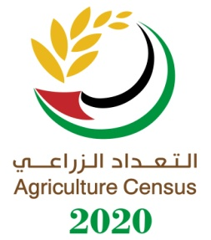
P.O BOX 1647, Ramallah, Palestine.
Tel: (972/970) 2 2982700
Fax: ( 972/970) 2 2982710
Toll free.: 1800300300
E-Mail diwan@pcbs.gov.ps
Web-Site: http://www.pcbs.gov.ps

