Note to users:

Industrial Production index for February 2020 has been revised accordance to latest international recommendations in this regard.

Old press release

Industrial Production Index-February 2020

Increase in the Industrial Production Index (IPI) in Palestine during February 2020
The overall IPI in Palestine reached 105.71 during February 2020 with an increase of 3.98% compared to January 2020 (Base Year 2018 = 100).

IPI for February 2020 increased due to the increase in the activities of Electricity, Gas, Steam and Air Conditioning Supply by 4.22% which had a share of 11.95% of the total industry, the activities of Manufacturing Industry by 4.01% which had a share of 82.98% of the total industry, the activities of Water Supply, Sewerage, Waste Management and Remediation by 2.96% which had a share of 2.39% of the total industry, and the activities of Mining and Quarrying by 2.29% which had a share of 2.68% of the total industry.

For more information, please contact:

Palestinian Central Bureau of Statistics
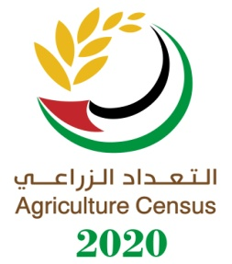
P.O BOX 1647, Ramallah, Palestine.
Tel: (972/970) 2 2982700
Fax: ( 972/970) 2 2982710
Toll free.: 1800300300
E-Mail diwan@pcbs.gov.ps
Web-Site: http://www.pcbs.gov.ps

