Palestinian Central Bureau of Statistics (PCBS)

The Preliminary Results of the Palestinian Registered External Trade In Goods of March,03/2020

In parallel with the beginning of the impact of COVID - 19 pandemic during March 2020 in Palestine and the world: Foreign trade witnessed a decrease in the registered exports of goods* by 17% compared to the previous month, and a decline by 29% compared to the corresponding month in 2019.

Exports in Goods
Exports decreased in March, 2020 by 17% compared to February, 2020. It also decreased by 29% compared to March, 2019 and reached USD 66.3 Million.

Exports to Israel decreased in March, 2020 by 17% compared to February, 2020 and it represented 82% of total exports in March, 2020.

At the same time, exports to other countries decreased by 14% during the same period compared to February, 2020 and reached USD 11.9 Million

Imports in Goods
Imports decreased in March, 2020 by 5% compared to February, 2020. It also decreased by 12% compared to March, 2019 and reached USD 401.6 Million.

Imports from Israel decreased by 9% in March, 2020 compared to February, 2020 and it represented 53% of total imports in March, 2020.

On the other hand, imports from other countries increased by 1% compared to February, 2020.
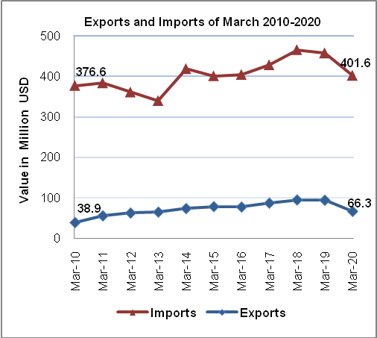
Trade Balance on Registered Goods
The trade balance which represents the difference between exports and imports showed a decrease in trade deficit by 2% in March, 2020 compared to February, 2020. It also decreased by 8% compared to March, 2019 and reached USD 335.3 Million.

(*): Includes actual data received from official sources.

